REMEMBERING OUR FALLEN
Tribute Towers of America’s Fallen from The Global War on Terror

NATIONAL TOUR will stop at the New Philadelphia VFW Post 1445 8/28/2025-9/1/2025 441 Park Ave NW New Philadelphia, Ohio

A very emotional exhibit, Remembering Our Fallen will soon be displayed at the New Philadelphia VFW Post 1445 to remind Americans of the ultimate sacrifice made by those who died from wounds suffered in Iraq and Afghanistan while wearing our country’s uniform.

The memorial includes 34 Tribute Towers with military and personal photos of almost 5,391 of our nation’s military Fallen from 9/11/2001 to 8/30/2021. This memorial was unveiled nationally at the steps of the Lincoln Memorial in Washington, D.C. in late 2017.
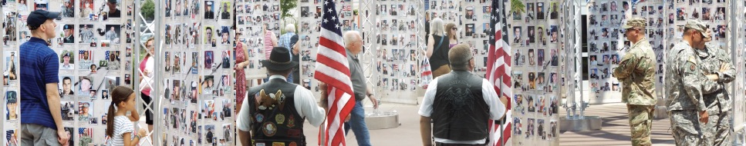
Organizers are still asking for help in contacting Gold Star families to include every single American who has died between 9-11-2001-8/30/2021 in The War on Terror. There is no cost to families. They may visit the web site: www.RememberingOurFallen.org and provide basic information and two photos for their Fallen loved one.

This national memorial also includes Tribute Towers that recognize our servicemen and women who died from training accidents or attacks while stationed stateside or on overseas bases. Those who return from war with the invisible wounds of Post-Traumatic Stress and succumb to suicide are also included to recognize the tragedy of PTS.

“We can never forget those who sacrificed everything for our freedom. We must remember these American Heroes and speak their names when we see their family members,” said Bill Williams, Vice President and co-founder of Patriotic Productions, the non-profit responsible for this memorial. “This memorial is created to travel, stopping in cities and communities all across the nation so more people will have the opportunity to honor and remember our Fallen from the longest wars in our nation’s history. We are thankful to ___________________________ for hosting this beautiful and somber memorial.”

The tour schedule and additional information are available at: www.RememberingOurFallen.org

Patriotic Productions is a 501 c. 3. non-profit organization with offices in Omaha, Nebraska and Irvine, California, with a mission of honoring our military. Remembering Our Fallen is the primary focus; however, Patriotic Productions has also taken 3,500 veterans of World War II, Korea, Vietnam, Iraq & Afghanistan on 13 Flights of Honor to Washington, D.C. since 2008. www.PatrioticProductions.org

